**Flood monitoring and early warning**

**PHASE-5**

**Chapter: 1 Introduction:**

The Internet of Things (IoT)-powered flood monitoring and early warning systems are a vital development in public safety and catastrophe management. These systems make use of contemporary technology to gather data in real-time, process it, and send out notifications in a timely manner to lessen the destructive effects of floods. We'll look at the idea of flood monitoring and early warning via IoT in this introduction.

An essential component of environmental preservation and catastrophe management is flood monitoring. It is crucial to have reliable and effective monitoring systems in place since floods are occurring more frequently and with greater severity globally. The Internet of Things, or IoT, is a potent technology that has the potential to completely change flood monitoring by facilitating real-time data collecting and processing, strengthening early warning systems, and facilitating better response times.

The Internet of Things (IoT) is the network of physical items, sensors, and gadgets that are networked and able to exchange data over the internet. IoT makes it possible to deploy a broad range of sensors and devices for flood monitoring that are capable of tracking several environmental data like water levels, rainfall, weather, and water quality. These sensors have the ability to send data to a central platform, where it is examined, processed, and distributed to the appropriate parties.

**Chapter: 2 DESCRIPTION**

The Internet of Things (IoT)-powered flood monitoring and early warning systems have emerged as crucial instruments for reducing the effects of floods on infrastructure, communities, and the environment. These technologies assist prevent property damage and save lives during flood events by collecting, analyzing, and disseminating vital information quickly.

**Chapter: 3 LIMITATIONS**

* Coverage and Facilities
* Expense and Execution
* Delays in Communication
* Overloading Data
* limited ability to respond
* Data accuracy and availability
* Difficulties with evacuation

**CHAPTER:4 MODULE**

**SENSOR**

A range of sensors and monitoring technologies are used in flood monitoring to collect information on water levels, precipitation, and other pertinent factors. These sensors are essential for tracking flood events and issuing early warnings.

**ULTRASONIC SENSOR**

Sound waves are used by ultrasonic sensors to gauge the water level in lakes, reservoirs, and rivers. They are frequently employed in locations where debris interference may be a problem for float-operated sensors.

**RIVER GAUGE SENSOR**

River gauges, also known as stage sensors, are devices that gauge the water level, or stage, in rivers, streams, and other bodies of water. Radar sensors, pressure transducers, and float-operated sensors are examples of common types.

The data from these sensors, which are frequently included in integrated flood monitoring and early warning systems, is evaluated in real-time to give communities and relevant authorities accurate and timely flood alerts and information.

**CHAPTER:5 PROGRAM**

//Early Flood Detection Using IOT ~ A project by Sabyasachi Ghosh

//<LiquidCrystal.h> is the library for using the LCD 16x2

#include <LiquidCrystal.h>

//"DHT.h" is the library for using the Temperature sensor DHT22

#include "DHT.h"

#define DHTPIN A0

  //here we are initialising a pin for DHT22

#define DHTTYPE DHT22

  //We have to declare the type of DHT sensor we are using for its correct functionality

LiquidCrystal lcd(2,3,4,5,6,7);

    // Create an instance of the LiquidCrystal library

DHT dht(DHTPIN, DHTTYPE);

        // Create an instance of the DHT library for the DHT22 sensor

const int in=8;

    //This is the ECHO pin of The Ultrasonic sensor HC-SR04

const int out=9;

     //This is the TRIG pin of the ultrasonic Sensor HC-SR04

// Define pin numbers for various components

const int green=10;

const int orange=11;

const int red=12;

const int buzz=13;

void setup()

{

  // Start serial communication with a baud rate of 9600

  Serial.begin(9600);

  // Initialize the LCD with 16 columns and 2 rows

  lcd.begin(16, 2);

  // Set pin modes for various components

  pinMode(in, INPUT);

  pinMode(out, OUTPUT);

  pinMode(green, OUTPUT);

  pinMode(orange, OUTPUT);

  pinMode(red, OUTPUT);

  pinMode(buzz, OUTPUT);

  // Initialize the DHT sensor

  dht.begin();

  // Set initial states for LEDs and buzzer to LOW (off)

  digitalWrite(green,LOW);

  digitalWrite(orange,LOW);

  digitalWrite(red,LOW);

  digitalWrite(buzz,LOW);

  // Display a startup message on the LCD

  lcd.setCursor(0, 0);

  lcd.print("Flood Monitoring");

  lcd.setCursor(0,1);

  lcd.print("Alerting System");

  // Wait for 5 seconds and then clear the LCD

  delay(5000);

  lcd.clear();

}

void loop()

{

  // Read temperature and humidity from the DHT22 sensor

  float T = dht.readTemperature();

  float H = dht.readHumidity();

  // Check if the sensor data is valid

  if (isnan(H) && isnan(T)) {

    lcd.print("ERROR");

    return;

  }

  float f = dht.readTemperature(true);

  // Read distance from the ultrasonic sensor (HC-SR04)

  long dur;

  long dist;

  long per;

  digitalWrite(out,LOW);

  delayMicroseconds(2);

  digitalWrite(out,HIGH);

  delayMicroseconds(10);

  digitalWrite(out,LOW);

  dur=pulseIn(in,HIGH);

  dist=(dur*0.034)/2;

  // Map the distance value to a percentage value

  per=map(dist,10.5,2,0,100);

  // Ensure that the percentage value is within bounds

  if(per<0)

  {

    per=0;

  }

  if(per>100)

  {

    per=100;

  }

  // Print sensor data and percentage value to serial

  Serial.print(("Humidity: "));

  Serial.print(H);

  Serial.print(("%  Temperature: "));

  Serial.print(T);

  Serial.print("%   Water Level:");

  Serial.println(String(per));

  lcd.setCursor(0,0);

  lcd.print("Temperature:");

  lcd.setCursor(0,1);

  lcd.print("Humidity   :");

  lcd.setCursor(12,0);

  lcd.print(T);

  lcd.setCursor(12,1);

  lcd.print(H);

  delay(1000);

  lcd.clear();

  lcd.print("Water Level:");

  lcd.print(String(per));

  lcd.print("%  ");

  // Check water level and set alert levels

  if(dist<=3)

  {

      lcd.setCursor(0,1);

      lcd.print("Red Alert!   ");

      digitalWrite(red,HIGH);

      digitalWrite(green,LOW);

      digitalWrite(orange,LOW);

      digitalWrite(buzz,HIGH);

      delay(2000);

      digitalWrite(buzz,LOW);

      delay(2000);

      digitalWrite(buzz,HIGH);

      delay(2000);

      digitalWrite(buzz,LOW);

      delay(2000);

  }

  else if(dist<=10)

  {

      lcd.setCursor(0,1);

    lcd.print("Orange Alert!  ");

    digitalWrite(orange,HIGH);

    digitalWrite(red,LOW);

    digitalWrite(green,LOW);

    digitalWrite(buzz,HIGH);

    delay(3000);

    digitalWrite(buzz,LOW);

    delay(3000);

  }else

  {

     lcd.setCursor(0,1);

    lcd.print("Green Alert!  ");

    digitalWrite(green,HIGH);

    digitalWrite(orange,LOW);

    digitalWrite(red,LOW);

    digitalWrite(buzz,LOW);

  }

}

RESULT:

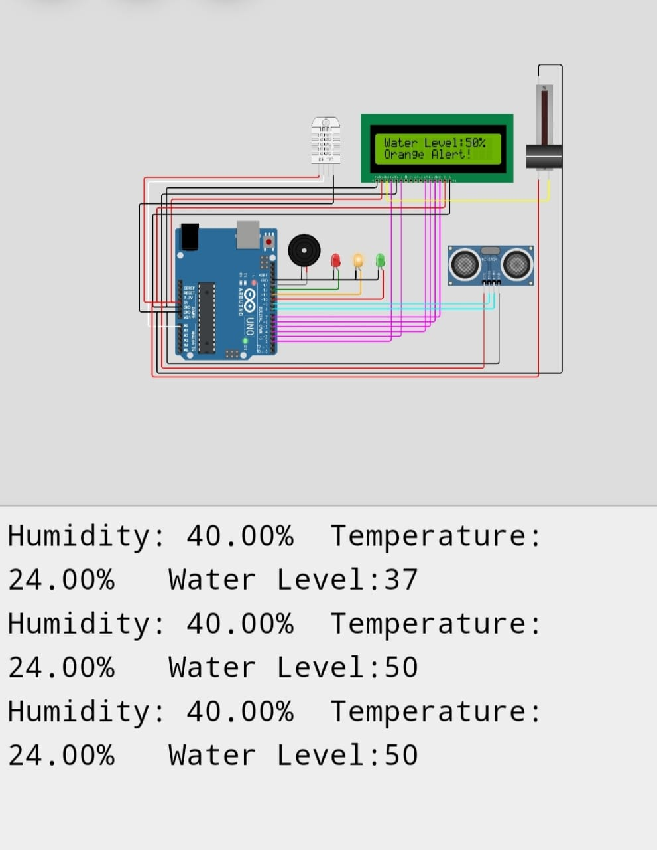

**CHAPTER:7 CONCLUSION**

In summary, IoT-based flood monitoring is a very promising and successful approach. It makes it possible to collect and analyze data in real-time, improving early warning systems and disaster management. We can greatly increase our capacity to observe, anticipate, and react to flood events by placing sensors and connected devices in flood-prone areas. This will ultimately help save lives and lessen the damage that floods do to infrastructure and communities. With climate change and rising flood risks, this technology has the potential to revolutionize flood management and boost resilience.